United Way of Greater Greensboro
2022-23 Short Success Stories

Helping Youth Transition From Cradle to Career


Rosalia’s Story (with photo)
After having her son, Rosalia overcame postpartum depression and found herself wanting to do as much as possible to help her son thrive. Thanks to your support, and United Way’s strategy that creates pathways out of poverty, Rosalia and her son received support through United Way’s Thriving at 3 educational program. Rosalia quickly learned new parenting skills to help her son’s development, and she connected with a peer group that has also proven to be supportive. “My son and I have learned to understand each other better, he is more outgoing, and we’re both learning better communication skills,” said Rosalia.

Kahina’s Story (no photo)
An Algerian immigrant, Kahina was not an English speaker when she moved to the United States. She quickly discovered she needed to learn the language for her own personal prospects and to ensure educational success for her young daughters. Thanks to your support, and United Way’s strategy that creates pathways out of poverty, Kahina and her daughters have been empowered to succeed by learning English. Together with her daughters, they have excelled with virtual learning throughout the pandemic, skyrocketing from beginner to advanced English literacy levels in just a single year. With a community of fellow learners from all walks of life by their side, Kahina and her daughters are on an encouraging path of success.

Helping Adults Land Jobs and Increase Income

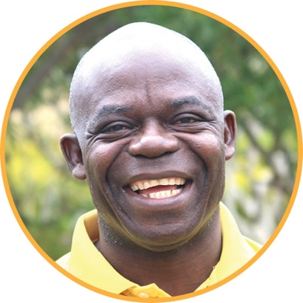
Larry’s Story (with photo)
For years Larry struggled maintaining employment because he could not read. After losing yet again another job, it was time for a change. Thanks to your support, and United Way’s strategy that creates pathways out of poverty, Larry finished a class that taught him how to read, he landed a job, received a promotion with a raise and is considered a model employee by the company. His next step is enrolling in a GED class. “Thank you. I had kind of given up on myself and didn’t know what to do. Then you guys came along and gave me hope,” said Larry.


Robin’s Story (with photo)
After losing a job of over twenty years, gaps in her technical knowledge and the challenge of finding new connections, Robin was finding it hard to get back on her feet. Thanks to your support, and United Way’s strategy that creates pathways out of poverty, Robin learned new skills, her confidence was restored, and she returned to the local workforce!

Providing Access to Basic Needs and Healthcare


Jarvis’ Story (with photo)
Due to health and financial issues, Jarvis couldn’t maintain his lifelong home and as a result, it fell into disrepair. Soon, the critical repairs necessary to keep the house safe worried Jarvis that he would lose the home where he grew up. Thanks to your support, and United Way’s strategy that creates pathways out of poverty, the home received needed repairs and Jarvis received the support he needed to stay housed. “I can live longer knowing these changes have been made, and I have something to look forward to now. I just wish my mom could see it,” said Jarvis.

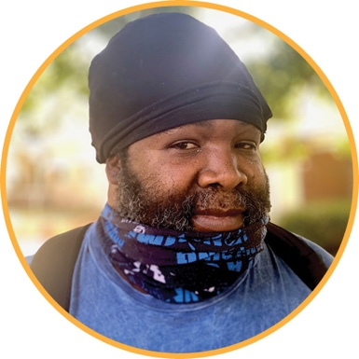
Jim’s Story (with photo)
As a Haitian immigrant, Jim enlisted in the United States Army and serving as a Ranger to give back to others. After returning from duty, he suffered from PTSD, and unexpectedly lost his sole family support system. Jim found himself without a home, dealing with drug addiction on his own. Thanks to your support, and United Way’s strategy that creates pathways out of poverty, Jim was connected to a network of case managers and has been granted access to housing and transportation security. Because of these crucial resources, Jim feels he is now able to learn from his mistakes and get his life back on track.

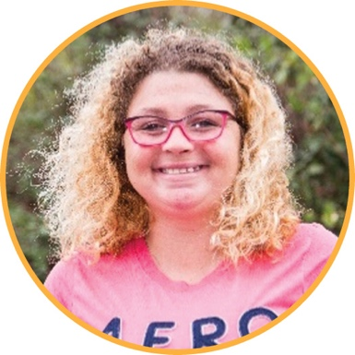
Cherie’s Story (with photo)
As a survivor of domestic abuse, Cherie tried to return her family to normal life over the years. But juggling the safety of her children while coping with PTSD from her abuse proved daunting. Thanks to your support, and United Way’s strategy that creates pathways out of poverty, Cherie discovered a local support system and counseling has helped her conquer the fear of her past. With a newly realized inner strength, Cherie feels the generational cycle of domestic violence has been broken for her family and she has the resources to thrive.

Misty’s Story (no photo)
Misty’s story rings familiar to many who fall though systemic cracks: a lost job means no access to health insurance and qualifying for Medicaid was tricky. When her son expressed he needed mental health counseling, Misty felt like they had to forego costly counseling services so that she could focus on finding a job. Thanks to your support, and United Way’s strategy that creates pathways out of poverty, Misty was able to access flexible rates for counseling services, which eased her family’s mental burdens, and she was able to focus on landing a job.

Bundled Services that Remove Barriers

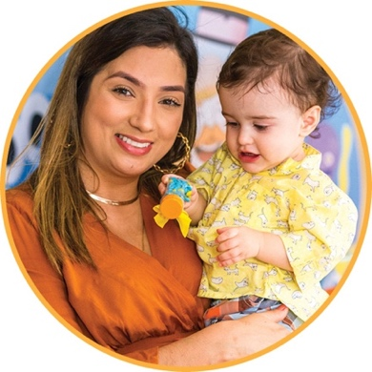
Jamie’s Story (with photo)
Jamie joined United Way’s Family Success Center at Guilford Child Development in 2017, with the goal of earning her GED. As a single mother, she was able to place her daughter in childcare and get her enrolled with a Headstart program. Once the pandemic hit and FSC had to shut down in-person classes, Jamie lost interest in pursuing her education. When FSC re-opened in-person classes, Jamie was excited to get back to her first priority: her education. She now attends regularly and plans to earn her GED this year and then find employment. She received a monetary donation to assist her in the meantime. With the help of her coach, Jamie opened her first bank account, purchased clothing for her daughter and food for the household. Opening the bank account is moving her toward greater financial responsibility and saving, and Jamie’s future is full of possibility!

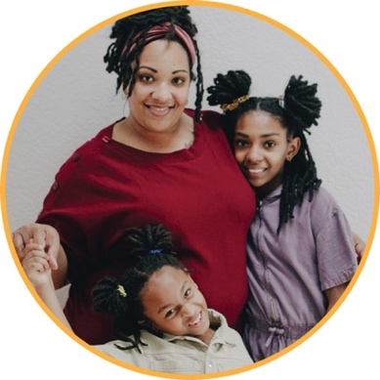
Linda’s Story (with photo)
Linda enrolled in United Way’s Family Success Center (FSC) at Salvation Army Center of Hope in 2020, as a college student and single mother of two children. Her primary goal was to become a first-time homeowner. She completed a Money Bootcamp class right before the pandemic. She found this class to be helpful and signed up for additional individual financial counseling to work on eliminating debt and increasing her credit score. While taking classes at FSC, Linda continued working toward a college degree, and in May 2022, graduated from NC A&T State University with honors, receiving her Bachelor’s Degree in Liberal Arts and Science. As the first college graduate in her family, Linda wants to open her own consignment shop. After some discussion with her FSC coach, she now has plans to do just that!

