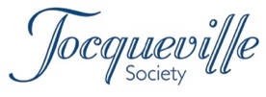
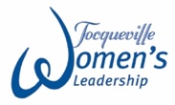
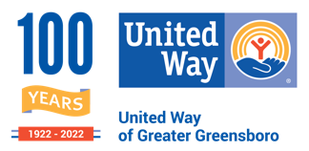
Tocqueville
Donation Form

Thank YOU for being a leader in our community!
You are supporting holistic initiatives and partnerships that are ending local poverty.

Name
Street Address
City, State, Zip

Your 2021 generous gift was $ ____

As we continue to recover from the impacts of a pandemic, and face rising costs of just about everything, local people living in poverty have been impacted the most. The gaps have widened, and the needs are greater than ever. If you can, please consider increasing your gift this year.

YES! You can count on my/our 2022 gift of $________ to United Way to help local children, families and adults move from poverty to possibility.

I/we plan to pay:

- Payment enclosed ͏
- Donor advised fund

Remind me/us:
- Once

- Monthly ͏
- Quarterly ͏
- Semi-annually

Reminder start date: ___/___/___

I would like to include this contribution
in my employer’s campaign – Company name: ________________________________

Please recognize my/our gift as: ________________________________
Print name(s) as you wish to be listed in recognition materials

Signature: ___________________________ Date: ___________

Please return your donation form by October 21, 2022.
The first $10,000 of a Tocqueville Society member’s gift is undesignated and supports United Way’s strategic focus.

For additional information:
- I/we have included United Way in my/our estate plans
- I/we wish to learn more about endowing my/our Tocqueville gift
Elizabeth Green at 336-378-6607
1500 Yanceyville Street
Greensboro NC, 27405

