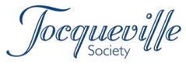
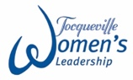
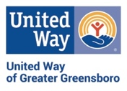
2022 Step Up to Tocqueville
Pledge Form

Year | Annual Pledge/Gift | Recognition Amount
1 | $5,000 | $10,000
2 | $7,500 | $10,000
3 | $10,000 | $10,000
The Step-Up Initiative recognizes contributions from leaders joining the Tocqueville Society or Tocqueville Women’s Leadership for the first time. It is a three-year plan that offers full Tocqueville membership to individuals who give at least $5,000 in the first year and commit to “stepping up” to reach $10,000 within three years.

NAME: ________________________________________________________________________________

ADDRESS: ________________________________________________________________________________

RECGONITION NAME: _________________________________________________________________

CELL PHONE NUMBER: _________________________________________________________________

EMAIL ADDRESS: _________________________________________________________________

I/we plan to pay: Payment enclosed Donor advised fund

Remind me/us: Once Monthly Quarterly Semi-annually

Reminder start date: ___/___/___

Stock/securities Brokerage firm: _______________________________________________________
Contact person: ______________________________________________________

I would like to include this contribution
in my employer’s campaign – Company name: ______________________________________________

Signature: _______________________________________ Date: ___________________

Payment of this pledge is encouraged prior to Dec. 31, 2022.
The first $10,000 of a Tocqueville Society member’s gift is undesignated and supports United Way’s strategic focus.

For additional information:
- I/we have included United Way in my/our estate plans
- I/we wish to learn more about United Way’s Legacy Society
- I/we wish to learn more about endowing my/our Tocqueville gift
Elizabeth Green at 336-378-6607
1500 Yanceyville Street
Greensboro NC, 27405

