UNITED WAY OF GREATER GREENSBORO 2023 SHARED ePLEDGE PLATFORM SET-UP FORM

COMPANY INFORMATION
Click or tap here to enter text. Click or tap here to enter text.
Company Name Andar Acct. No.
Campaign and ePledge Contacts | Name | Email | Phone | Needs eAdmin access
Employee Campaign Manager | Name | Email address | (xxx) xxx-xxx | Yes/No
Payroll/Billing | Name | Email address | (xxx) xxx-xxx | Yes/No
IT Contact | Name | Email address | (xxx) xxx-xxx | Yes/No
Other: Please note what for | Name | Email address | (xxx) xxx-xxx | Yes/No
☐ I acknowledge that my company uses either the latest version of Google Chrome or MS Edge
CAMPAIGN TIMELINE
- ePledge kick off date: Click or tap to enter a date. (Can be different than your campaign start date. Some companies elect to open ePledge a week prior to the campaign starting)
- ePledge close date: Click or tap to enter a date.
NOTE: the kick off and close dates can be changed, but having a rough estimate helps the web developer with his due dates as we have multiple sites getting built at the same time. ePledge Set-up Form is due back to UWGG 14 business days before kickoff date

EPLEDGE SET-UP
☐ Company Logo: email a high-resolution jpeg., no more than 1inch to Julia.Thomas@unitedwaygso.org
☐ Company will share an employee file containing at minimum Employee ID, Name and Email Address with UWGG (DUE to UWGG 10 business days prior to kick off date) UWGG will connect with your IT Contact above to determine best method of file sharing
Employee Access: ☐Email (employee file required) ☐Generic Link
If using email:
- Message Schedule:
  - Kick off email: Click or tap to enter a date.
  - Reminder email(s): Enter date(s) or frequency
  - Wrap-up/Final reminder: Click or tap to enter a date.
- Send the White List Settings (below) to your IT department, to ensure UWGG emails don’t go to spam
- Message Content: below is this year’s kickoff email. Messaging specific to your campaign comes from you.

Payroll Options
- Number of pay periods: List number of pay periods. If the number of pay periods varies by employee, list options available
  - Can donors alter this when pledging? ☐Yes ☐No
  - If yes, what options can they change it to? One time, quarterly, other.
- Payroll file due back to company’s payroll office: Click or tap to enter a date.
- Payroll deductions begin on: ☐1/1/24 ☐Other: Click or tap to enter a date.

Will you allow donors to edit pledges after they submit it online ☐Yes ☐No
This feature is unavailable once your campaign closes.

Email White List Settings

Please review the information below regarding the Email Communication Service. The Email Communications Service affects campaign-related emails, newsletters, and other forms of email communications used to keep you informed about our work and upcoming events.

The Email Communication Service sending/originating IP Addresses listed below should be added to spam filter whitelists and set as exempt to rate controls. Not whitelisting the sending/originating IP Addresses or not exempting them from rate controls can lead to rejected emails or slow delivery.

Email Communication Service sending/originating IP Addresses:
- smtp1.upicsolutions.net (52.86.171.35)
- smtp2.upicsolutions.net (34.232.26.125)
- smtp3.upicsolutions.net (34.230.104.208)

If the Email Communication Service IP Addresses cannot be whitelisted and exempted from rate controls, several features have been implemented to help reduce the misclassification of email communications from United Way. The first feature is the use of SPF records and the second is DKIM signing of all emails from our Email Communication Service. The final enhancement, DMARC, will be implemented in late 2018. To find out more about these features, please use the URL links provided below.

SPF Record (Sender Policy Framework)
- This record defines what IP addresses can send emails on the behalf of a domain
- http://www.openspf.org/Introduction

DKIM Signing (DomainKeys Identified Mail)
- When an email is sent through the Campaign email service, it is automatically signed with a special signature.
- The receiving party verifies this signature by looking it up a special DNS record.
- http://www.dkim.org/#introduction

DMARC (Domain-based Message Authentication, Reporting & Conformance)
- DMARC builds on top of SPF and DKIM and helps define what should happen when a message fails checks through SPF and DKIM as well as where to send failure reports.
- https://dmarc.org/

eMail message content
KICK OFF SUBJECT: (GIVE TODAY) Your United Way campaign has started!

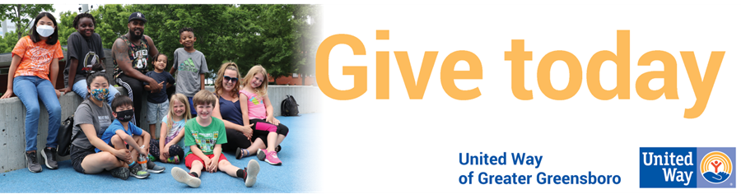

Dear (__________),

Your investment in United Way has a tremendous impact on our local community. Your gift creates opportunities and provides vital resources for our neighbors in need.

Your workplace campaign starts today! Make a gift to United Way and your investment stays local: Larry's story is just one example of how your support is helping individuals overcome poverty.

For years, Larry struggled to find stable employment because he was never taught to read. With the support of investors like you, Larry completed a reading class, secured a job, earned a promotion, and is now regarded as a model employee. His next goal is enrolling in a GED class.

United Way collaborates with community partners to fund programs and initiatives that empower individuals to escape poverty by:
- Helping youth transition from cradle to career
- Helping adults land jobs and increase income
- Providing access to basic needs and healthcare

Make a gift today and you will play a pivotal role in our mission to lift local individuals, families, and children out of generational poverty and shape the future of Greater Greensboro.

CLICK HERE TO MAKE YOUR GIFT TODAY!

Your partnership and compassion for our community makes a difference.

P.S. If you haven’t seen the power of your gift in action, visit UnitedWayGSO.org.

NOTE: This is your unique donation link. Please DO NOT FORWARD or share this link with others. By clicking the above link you will be securely and automatically logged into our Online Pledge System. When you complete your pledge, you’ll receive a confirmation email. If you have any questions or experience issues with the pledging system, please contact your Employee Campaign Manager, your United Way representative, or email support@unitedwaygso.org for support.

Visit our website.
United Way of Greater Greensboro | 1500 Yanceyville Street | Greensboro, NC 27405

